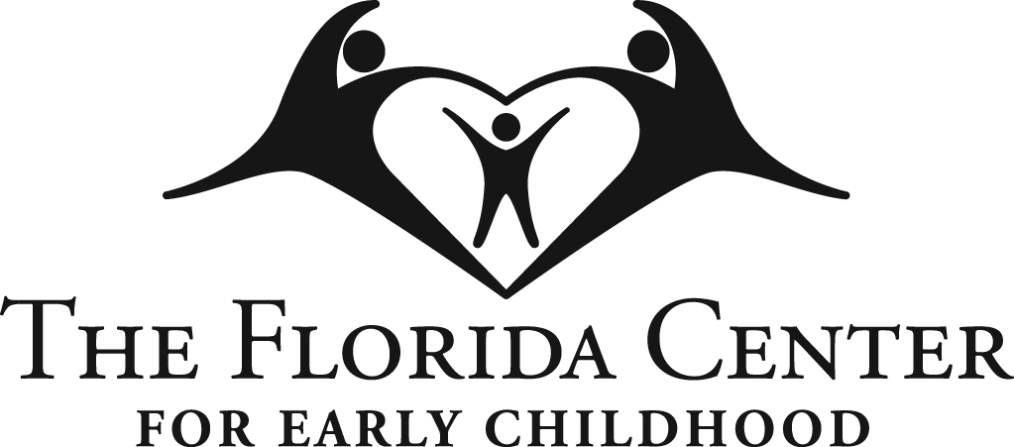 JOB DESCRIPTION

POSITION: Supervisor of FASD Services – Sarasota

EMPLOYEE NAME:

GENERAL STATEMENT OF DUTIES: This position plays a key leadership role in supporting, expanding, and sustaining Fetal Alcohol Spectrum Disorders (FASD) services in the Sarasota community. This position is responsible for outreach, program development, team support, and community engagement. The Supervisor serves as a liaison between The Florida Center’s Sarasota location and the broader FASD program team to ensure the effective delivery of services, integration of FASD-informed practices, and coordination across departments and community partners.

REPORTS TO: Statewide Director of FASD Services

STATUS: Full Time, Non-Exempt

EDUCATION/EXPERIENCE
- Master’s Degree in Health-related field, licensed preferred
- Minimum of 5 years clinical experience providing assessment, care planning, and treatment to children and families. Multidisciplinary experience preferred.
- Two years’ experience supervising staff.
- Active license under Florida board 491 as LMHC, LCSW, or LMFT (Preferred)
- Qualified Supervisor designation (preferred)
- Understanding of the clinical needs of neurodivergent individuals and their caregivers (preferred)
PRINCIPLE DUTIES
- Contribute to increasing awareness of FASD by participating in marketing and development initiatives, as guided by clinic director with a focus on Sarasota and surrounding communities.
- Facilitate, coordinate and supervise the Sarasota multidisciplinary FASD team (Speech/Language Pathologists, Occupational Therapists, Neuropsychologists, Mental Health Clinicians and interns, and Administrative Intake Coordinator)
- Provide supervision for the Parent Advocate position to ensure timely support for families and to encourage ongoing efforts to develop new and effective ways to engage with them.
- Provide Supervision and Support for Mental Health clinicians located in Sarasota location
- Work with clinic director to ensure contract obligations are met or exceeded, including but not limited to number of evaluations conducted, demographics, numbers trained, and numbers linked to services/interventions
- Collect outcome data as required by funders and submit monthly to clinic director
- Coordinate and maintain FASD Intake Clinic procedures.
    - Supervise FASD Intake Clinic Coordinator.
    - Set clinic schedule. Responsible for appropriate clinic staffing at all times.
- Monitor FASD clinic referrals, follow up with all children/families referred. Routinely reviews waitlist with clinic director.
- Provide FASD Training as scheduled.
- Co-facilitate Weekly FASD Support Group.
- Supervise interns involved with the FASD clinic.
- Attends weekly/biweekly supervision with clinic director.
- Demonstrate active and ongoing collaboration both interagency and with other agency Departments.
- Contribute to improving access to FASD-informed services by becoming trained in evidence-based models for families raising a child with an FASD (Families Moving Forward; FASCETs), through internal initiatives such as Neurobehavioral Roundtables, and group consultation/supervision, and external initiatives such as recruiting Parent Advocates
- Contribute to ongoing quality improvement through outcome monitoring (client satisfaction surveys, client inquiries), fidelity monitoring, provider training/support, and after-action review
- Ensures office spaces and shared facilities are neat, tidy and organized.
- Other duties as assigned

PERFORMANCE REQUIREMENTS/PERSONAL QUALITIES
- Understanding and support of the mission of The Florida Center for Early Childhood and its programs
- Excellent oral and written communication skills, using a personalized, donor-centric approach to enhance retention and engagement
- Computer proficiency in Microsoft Office suite, especially Excel, Word, Outlook
- Detail-oriented with superb organizational skills
- Excellent customer service skills and positive attitude
- Ability to work independently as well as across teams
- Skilled in problem-solving, decision-making, and time management
- Ability to analyze data and processes
- Ability to handle multiple projects with fast-approaching deadlines and to manage stress under occasional high-pressure situations.
- Ability to maintain client and donor confidentiality according to established policies, federal and state statutes
- Ability to interpret, adapt and apply guidelines and procedures
- Professional appearance and behavior, including punctuality.
- Compliance with agency/state/legal mandates for reporting suspected abuse/maltreatment/neglect
- Actively participate in staff meetings and promote a culture of philanthropy
- Complete assigned paperwork in compliance with standards, including time sheets, mileage logs, leave requests, client records, client appointments and management information system.
- Ability to work in partnership with other team members.
- Valid Florida Driver License and full-time access to a reliable vehicle with appropriate insurance coverage.
- Ability to adhere to drug free workplace policy.

TYPICAL WORKING CONDITIONS
Office environment, automobile, community.

TYPICAL PHYSICAL DEMANDS
Requires individual to perform a broad range of activities. Requires full range of motion, including manual and finger dexterity and hand and eye coordination. Requires corrected vision, speech, and hearing to normal range, or special accommodations made of sufficient nature for completion of assigned tasks. Ability to lift 30 pounds. Occasionally requires working under stressful conditions or working irregular hours. Requires seated work at desk, including use of a computer. Ability to drive.

I hereby acknowledge I have read, understand, and accept the above Director of Marketing and Special Events job description as a condition of my employment.

Signature Date

Name (Print)

